Light Disarray

Café During the day, Lounge at night!

Mirowski, Arthur

  Web Programming 1

## Light Disarray

By day, we’re a cozy café with an open-air vibe, perfect for sipping your favorite brews, including a selection of imported beers, and enjoying a relaxed atmosphere. As the sun sets, we transform into a vibrant bar and lounge, where our passion for mixology takes center stage. Our team loves to experiment with innovative drink creations while also serving up beloved classics, ensuring there’s something for everyone.

At Light Disarray, we believe in the power of community. Join us during the day for exciting events like our run club, group bike rides, and live DJ sets. As night falls, the energy ramps up with live music performances that invite you to dance the night away.

## The Website

### Purpose

Our website is your hub for all things happening at Light Disarray. You can explore our upcoming gigs and events, from lively DJ sets to captivating live music performances, ensuring you never miss anything.

Pay attention to our latest beverage creations, where our mixology team showcases innovative drinks. Whether you're joining us for a relaxing day or an energetic night out, our site will keep you in the loop about what’s happening at Light Disarray.

### Target Audience

The target audience for Light Disarray includes anyone who enjoys a beautifully blended cup of locally roasted coffee, whether you’re a casual drinker or a dedicated coffee connoisseur. We also attract night owls who love to sing and dance, welcoming those who appreciate live performances. We open our arms with those with a passion for beautifully crafted cocktails and those who appreciate a good pint of our imported beers. Light Disarray welcomes all, appealing to all individuals regardless of age, gender, or background.

### Planned Pages

#### Home

The “Home” page will give those interested in Light Disarray an introduction of what we are and what we stand for. The home page will showcase photos of your favourite cocktails, our lively nightlife and our beautiful cafe. The home page will have any updates or news regarding Light Disarray as well.

#### About us

The “About Us” page will give you a glimpse of how Light Disarray came to be and the passion we have to form a community we can be proud of.

#### Menu

The “Menu” aims to showcase our wide range of cocktails and beers.

#### Events

The “Events” page promotes all our scheduled upcoming events and will provide information about the events as well.

#### Hours of Operations

The “Hours of Operations” page will have our opening to closing hours, as well as days we may be closed.

### Logo

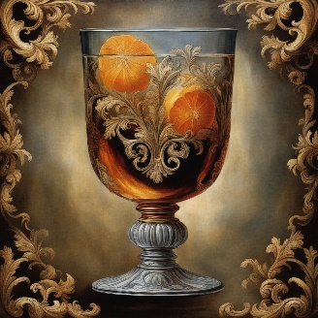

The logo for Light Disarray is an old fashioned In a cordial glass, with two tangerines. This image was created using AI, by [DeepAI](https://deepai.org/machine-learning-model/text2img). This image is permitted to be used for commercial use.

### Colour Palette

This colour palette was found on [Visme.co](https://visme.co/blog/website-color-schemes/). The simplicity of the colour palette brings a calming effect, as well as brown matching well with coffee.

#3E362E for text colour.

#865D36 as border

#AC8968 as background colour.

### Desktop Site Layout

### Mobile Site Layout

Navigation containing : Home, About Us, Menu, Hours of Operation, Events.